EXHIBITOR PROMOTION TOOL KIT
Help spread the word that you will be exhibiting at IMS2023! Research has shown that exhibitors who market their presence at shows to their customers and prospects have more favorable experiences and acquire more leads.

Take advantage of these free marketing tools to influence your peers, customers, and social media followers. Invite them to join you along with thousands of RF and microwave professionals in-person in San Diego this June.

Event Listing
IMS2023
11-16 June 2023
San Diego Convention Center
San Diego, CA

IMS2023 website: https://ims-ieee.org/ and be sure to include #IMS2023

Is someone from your company speaking during the technical program at IMS? Be sure to check out our Speaker Promotion Toolkit.
IMS Show Management is here to help you succeed. If you would like to customize any of the banners with your booth number or logo, please send an email to exhibits@horizonhouse.com and we will be happy to assist you.

Exhibitor Promotion Tool Kit
Social Media Images 2
Social Media Square Posts (1080x1080) 3
Social Media Vertical Posts (1080x1920) 3
Social Media Horizontal Posts (1600x900) 3
Email Signature (320x100) 2
Banner Ads (728x90) 2
Show Logos 2
Sample Posts and Tweets 2
Newsletter Blurb 2

Social Media Images
Share these social media badges and banners on your LinkedIn, Facebook, Instagram, and Twitter posts! Right-click and "Save Target as..." or "Save Image as..." to download.

Mention IMS2023 on socials!
Facebook | @IEEE.MTTS.IMS
Instagram | @mtt_ims
LinkedIn | @ieee-mtt-s-international-microwave-symposium-ims
Twitter | @MTT_IMS
YouTube | @mttims

Social Media Square Posts (1080x1080)
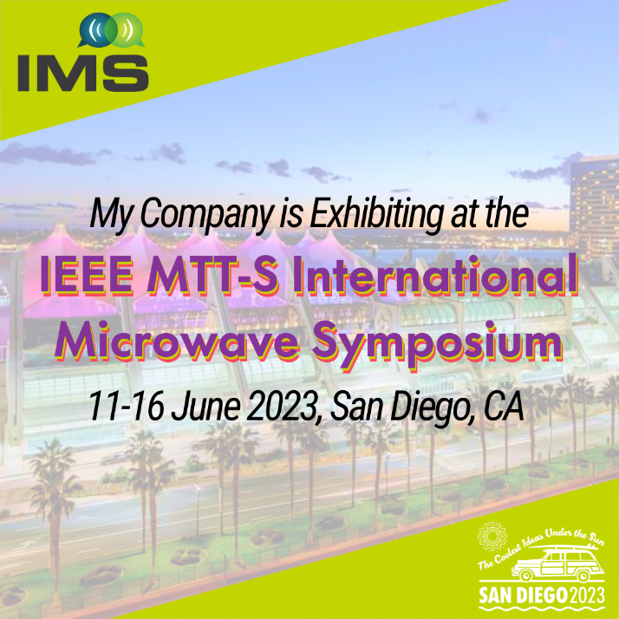
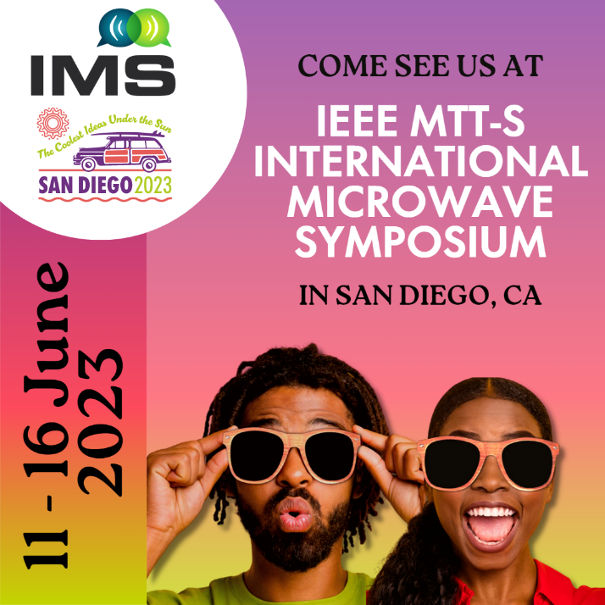

Social Media Vertical Posts (1080x1920)
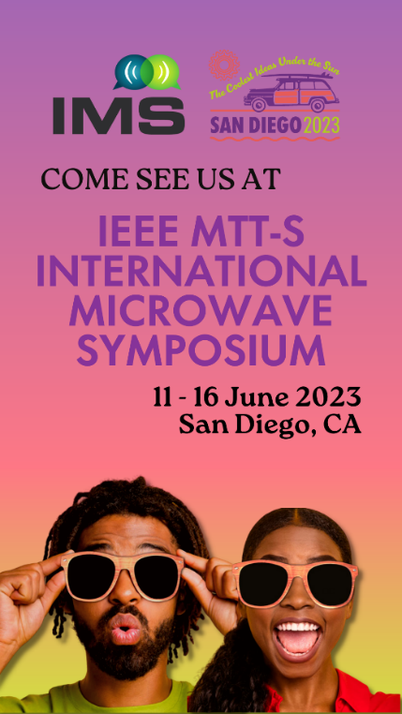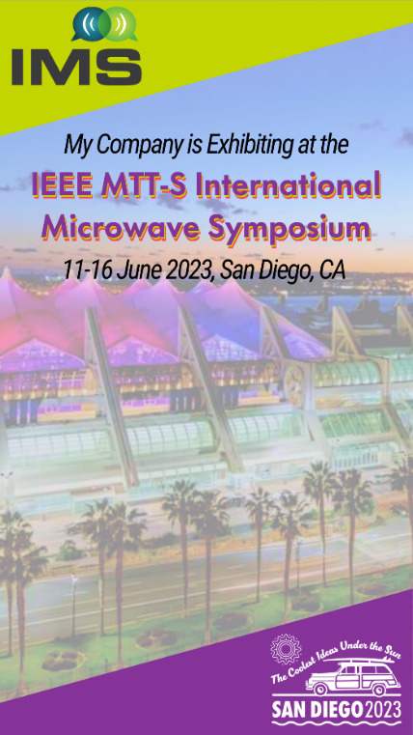

Social Media Horizontal Posts (1600x900)
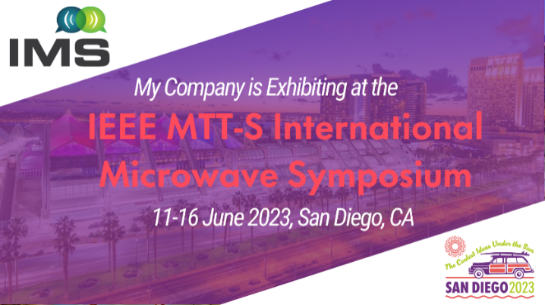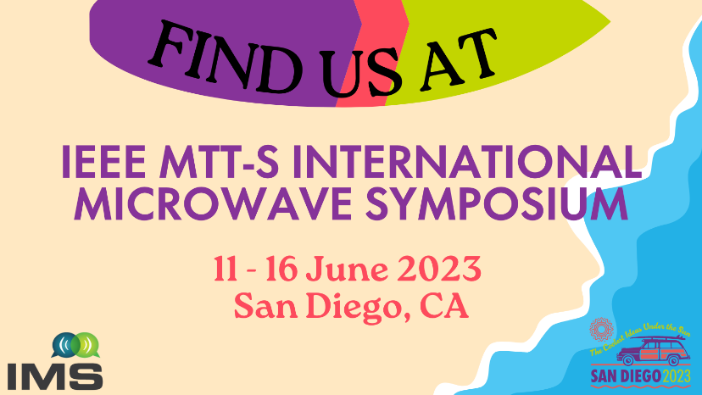
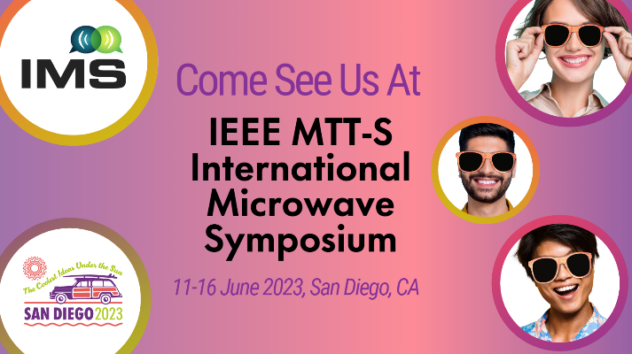

Email Signature (320x100)
Your e-mail signature is another subtle way to promote your presence at IMS2023. Right-click and "Save Target as..." or "Save Image as..." to download, then link the banner to https://ims-ieee.org.

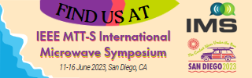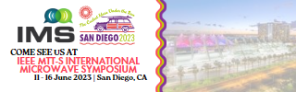

Banner Ads (728x90)
Include a banner ad on your website and in customer newsletters. Right-click and "Save Target as..." or "Save Image as..." to download then link the banner to https://ims-ieee.org.

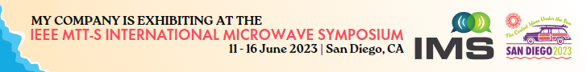

Show Logos
The IMS logo and IMS2023 San Diego graphic element are popular options to promote your participation at the event. Right-click and "Save Target as..." or "Save Image as..." to download then link the banner to https://ims-ieee.org.

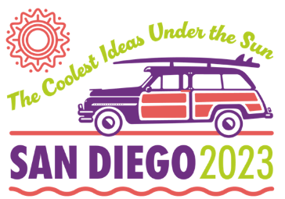

Sample Posts and Tweets
Not sure what to say on social media? Want to let your customers know you'll be there? Let us help get you started
- I'm exhibiting at #IMS2023! Check out what's going on https://ims-ieee.org/
- Who's ready for IMS in San Diego? I'm excited to be exhibiting at #IMS2023. https://ims-ieee.org/
- We at (insert company name) can’t wait to connect with the RF and microwave community at #IMS2023 https://ims-ieee.org/

Newsletter Blurb
Join us this June at the San Diego Convention Center as we come together in sunny southern California for the world’s premier RF and microwave industry conference and exhibition. This will be a great chance to re-establish connections and make new ones live and in person. With top-notch technical sessions, as well as hundreds of exhibitors to network with, you will want to mark your calendars and come explore the “Coolest Ideas Under the Sun” [insert company name] will be exhibiting in booth [insert booth #]. We hope you can join us!

