SDC1: Design of a self-interference cancellation coupler

- Your Technical Committee number and name:
MTT-24 Microwave/mm-Wave Radar, Sensing and Array Systems
MTT-4 Microwave Passive Components and Transmission Line Structures

- Description of competition and rules:
- Motivation: In monostatic continuous wave (CW) radar systems, the radar coupler is an important component as it separates the transmit (Tx) and receive (Rx) signals. This is particularly important in applications that require the highest precision, for example for contactless measurement of breathing and heartbeat of persons in medical applications.
- SDC Description: Students shall design a self-interference cancellation coupler for possible radar application in the 24 GHz ISM Band

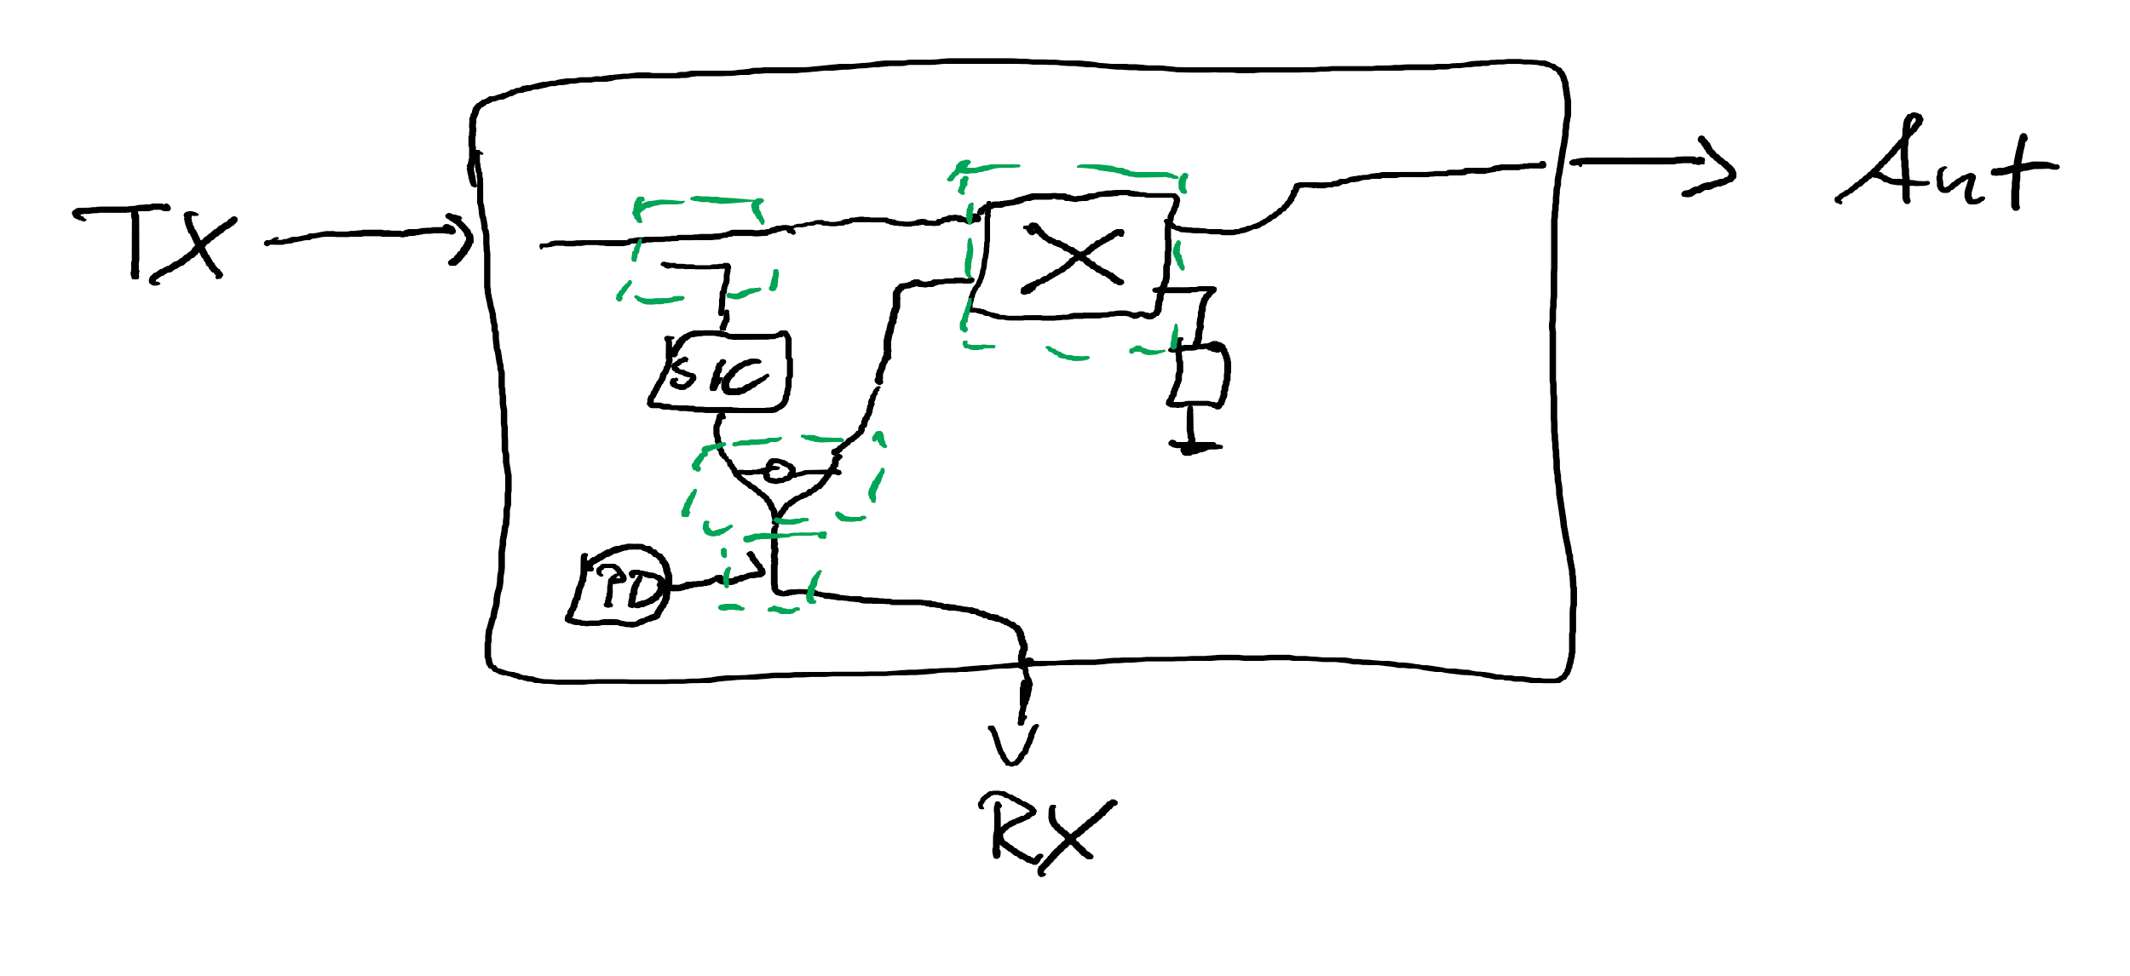
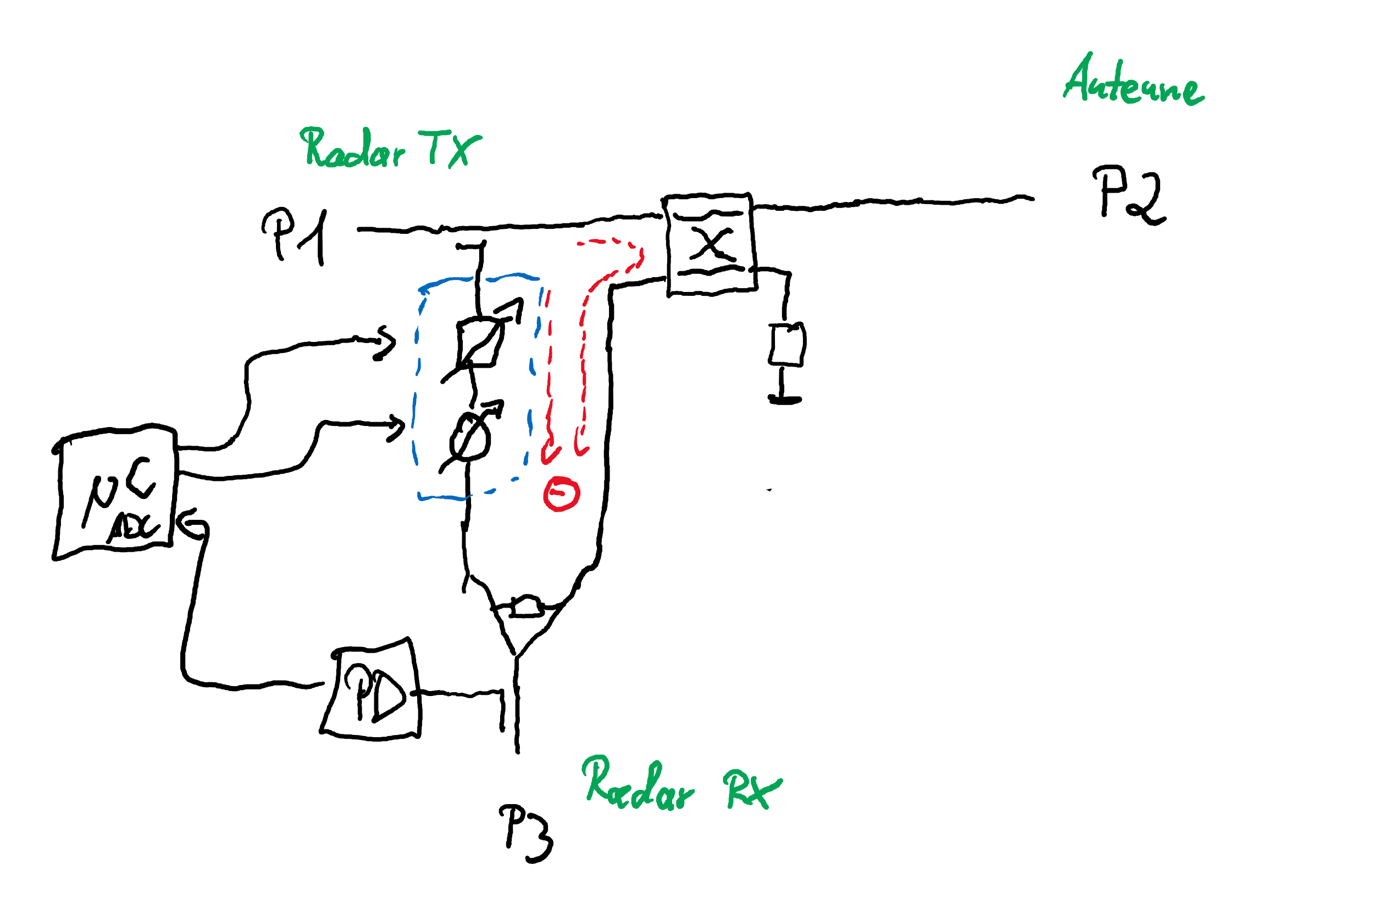

- Specifications / Evaluation setup:
  - 24 GHz ISM Band (24.0 – 24.25 GHz)
  - Evaluation over full band and/or single-tone test (e.g., each 50 MHz)
  - Sufficient settling time
  - Coupler, Divider, Splitter, Combiner, magnet-less Circulator must be realized as passive components on PCB
  - 3.5mm connectors for all RF Ports

- Evaluation criteria / FOM:
  - S11, S22, S32
  - S21, S31
  - size

- Constraints:
  - active components (amplification) allowed only in the phase/amplitude control cancellation branch!
  - All couplers must be transmission line based and designed on PCB
  - Judges will provide an additional “antenna emulator“ with different input matching (e.g. 10 – 15 dB) to challenge your cancellation concept
- Only “magnet free” circulators might be used!

- Contact names, email addresses, and phone numbers of competition organizers:
Fabian Lurz, fabian.lurz@ieee.org, +49 40 42878-3119
Christian Damm, damm@ieee.org, +49 731 5026360

- Criteria for judging:
- High Isolation / Low Crosstalk
- Low Insertion Loss
- Good Input and Output matching
- Compact size

- Detailed description of all equipment needed at the day of the competition:
Measurement and test equipment with 3.5mm or 2.92mm standard:
- 4-port VNA
- Three coaxial test cables
- Calibration kit (4-port electronic calibration module gladly preferred)

