Switched Acoustic Filter Module

Sponsoring MTT-S Technical Committees & Organizations
MTT-2 Microwave Acoustics
Qorvo
Menlo Microsystems
Keysight Technologies

Coordinators and Contacts
Holger Maune, TU Darmstadt
Andreas Link, Qorvo
Andreas Tag, Qorvo
Chris Giovanniello, Menlo Microsystems
Ian Burke, Menlo Microsystems

Please send all communication to mtt2sdc@listserv.ieee.org

Competition Summary
Microwave acoustic filters (SAW, BAW) are the prevailing filter technology in RF frontends of mobile handsets, due to their compactness, low price and high selectivity. To keep up with the demand for multiplexers, engineers are usually required to combine (off-the-shelf) SAW/BAW components with RF switches for a multi-band multiplex filter. In this competition, our sponsors Qorvo and Menlo Microsystems will provide the contestants with appropriate BAW and RF-MEMS components. The students are required to design and assemble a band 1/2/3/7 switched multiplexer module. The measurements will be taken at IMS’20 with support by Keysight Technologies. For simplification, only antenna and TX ports are switched. The RX bands are fed separately. Thus, the final circuit will have 6 ports (1× Tx; 1× Ant; 4× Rx).
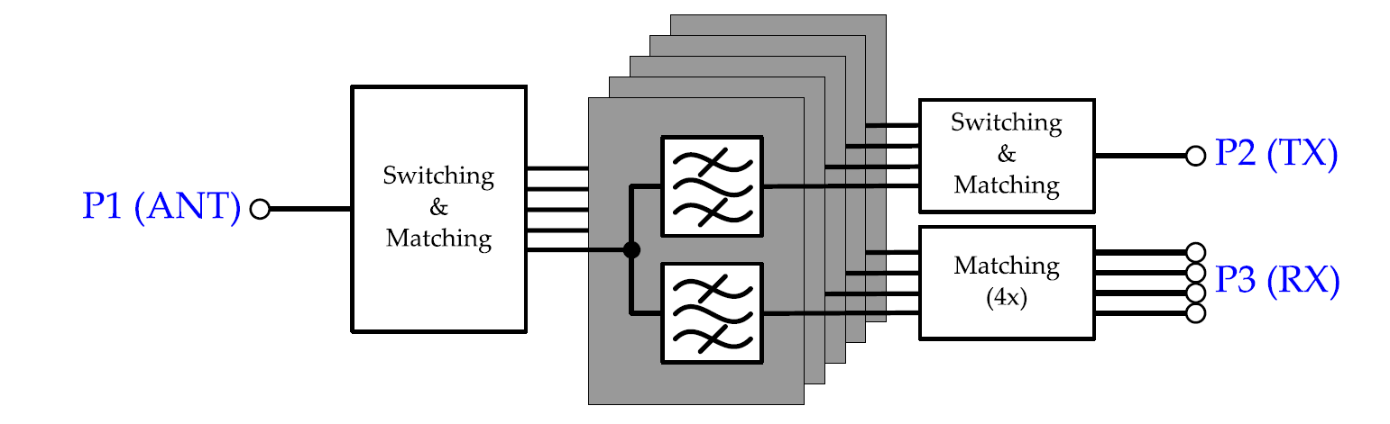
Figure 1: Schematic of the multiplexer module to be designed.

Detailed Competition Description and Rules

- The circuit must incorporate RF passive components only; using of amplifiers in the RF path is not allowed.
- The design must incorporate the QM23002 and QM26001 from Qorvo and MM5130 from Menlo Microsystems. Designs that deliberately spoil the isolation and stop-band rejection of the BAW components (e.g. bypass them or not use them at all), or use other high Q filter technology other than provided, are subject to disqualification.
- Components and their s-parameter data as well as additional information will be sent to the participants after registration. Please send an email to mtt2sdc@listserv.ieee.org.
- The circuit must be designed using commercially available components only.
- The circuit board must have a rectangular outline. Only the actual PCB size is measured (protruding RF and DC connectors are excluded). For handling simplification, boards might shall have a size of 5 × 5 cm². The module should be planar.
- The mechanical design should allow for internal inspection of all relevant components and circuit elements.
- Female 50Ω SMA end-launch connectors must be used. The connectors must be placed at the outer dimension of the board. Please allow enough space between the SMA connectors for proper connection with test cables.
- The frequency bands are defined as:

Band | TX band / MHz | RX band / MHz
1 | 1,920 – 1,980 | 2,110 – 2,170
2 | 1,850 – 1,910 | 1,930 – 1,990
3 | 1,710 – 1,785 | 1,805 – 1,880
7 | 2,500 – 2,570 | 2,620 – 2,690

- All measurements are referenced to 50 Ω impedance.
- We provide a standard DC power supply with 0 to 100 V DC for powering the RF-MEMS components. The connection will be 4mm banana plugs.
- The board must contain at least proper DC switches to select the band of interest. The implementation of a microcontroller with switching logic is optional.

Evaluation Criteria
The designs will be evaluated by a commission at the IMS’20 based on measurements taken on site. For the evaluation, only small signal parameters and the board design will be considered. In case of equal or very close results, the jury may consider additional criteria such as practicability and workmanship.

The performance will be evaluated based on six different states:

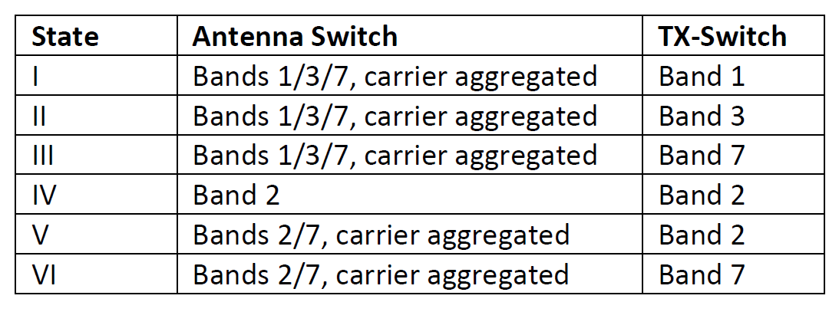
The figure of merit (in logarithmic domain) is defined as follows:
Designs with the highest FoM are favored. Please note, that the FoM will be negative valued. The s-parameter measurements will be taken at room temperature and -10 dBm power level at all ports. The values are the minimum/maximum values in all (carrier aggregated) bands assigned to the state/ports. The values will be rounded towards lower performance to the first decimal, e.g. |𝑠21|=−1.53dB⟹−1.6dB and |𝑠11|=−10.53dB⟹−10.5dB.

The board size must be 5 × 5 cm² at least. Boards, smaller in one or both dimensions, will be disqualified.
The device will be considered in case that
- all transmission parameters (|𝑠21|, |𝑠31|) ≥ -5 dB across the bands
- matching at all ports (|𝑠11|, |𝑠22|, |𝑠33|) ≤ -6 dB across the individual bands

In case one of the previous criteria is not met by the circuit presented at IMS’20 the circuit is not qualified for the contest.

How to Participate
Participants must register to the IMS Student Design Competition according to the rules posted on the IMS-2020 homepage. At the same time as the registration to IMS-2020 is made, the competitors must also register with the organizers of the competition. This is done by sending an e-mail containing the name of the team members and their contact details (e-mail preferred) to mtt2sdc@listserv.ieee.org with the subject line “IMS-2020 SDC1: Switched Acoustic Filter” no later than the official deadline announced on the IMS-2020 SDC homepage.
At least one member from each team must be present at the competition held during the IMS-2020. After the registration period ends, a time-table for the competition day will be made available, with the schedule of the 15 minutes slots of the participating teams. If no team member is present at the competition site within its slot, then the team may be considered as absent. Please also see the general IMS student design competition rules on the IMS-2020 SDC homepage.

Student Eligibility Criteria
- Students may enter as individuals or as a team. There may be no more than four students on a team. Each student may be a member of only one team. Each team may submit up to two entries but can receive an award for only one entry.
- To enter a competition, the student(s) must have been full-time student(s) (enrolled for a minimum of nine hours per term as graduate students or twelve hours per term as undergraduates) during the time the work was performed. There is no restriction on age.
- The student(s) must have a signed statement from their academic advisor that the work is principally the effort of the student(s).
- At least one of the students on a team must register for and attend the conference to demonstrate their design for evaluation during the contest day at IMS-2020.
- The student(s) must submit an entry form to the Student Design Competition co-chairs, who will also provide the form. Please send a copy of the form also to mtt2sdc@listserv.ieee.org to receive the components.
- The students should use the email address issued by their respective institutions for all communication regarding the competitions, rather than their personal emails (e.g., Gmail, Hotmail).

Awards
There will be two prizes awarded. The first and second place winner will receive $1,500 and $500, respectively. The winner is invited to submit a paper describing the design in the MTT’s Microwave Magazine.

