Spectrum Sensing Radio Receiver

Sponsoring MTT-S Technical Committees & Organizations
MTT-20

Coordinators and Contacts
Xun Luo, xun-luo@ieee.org
Zhizhang David Chen, z.chen@dal.ca

Competition Summary
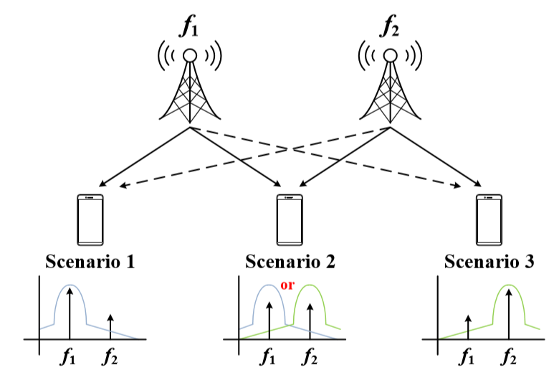
Figure 1. Configuration of the spectrum sensing function.

The ever developing of multi-standard wireless communications lead to a congest frequency spectrum. To improve communication quality and data transmission speed of wireless communication device (mobile phone, etc.), the cognitive radio receiver is proposed with adaptive and intelligent radio technology that can automatically detect and choose optimum channels and change operation parameters accordingly. They also have the ability to avoid the interference of adjacent channels.

This competition is aimed to design a simplified version of the cognitive radio receiver. Design entries will be judged based on the received data-rate, adjacent channel rejection, error vector magnitude (EVM) and power consumption of the receiver.

Detailed Competition Description and Rules
The objective of the project is to design a low-power high-speed receiver with spectrum sensing function. The receiver will receive two different signals from the signal generator and establish the communication with the signal generator. The receiver will operate under the following strict conditions:

- Transmitter (provided by the organizers on site): it sends two transmitted signals with one at 5.0 GHz and the other at 5.5 GHz and their modulations are at least 16 QAM.

- Digital data rate: should be at least 100 Mbps: the higher the higher scores.

- Output power of the receiver: it should be at least 0 dBm.

- Output IF frequency of the receiver (if any): it should be 500 MHz.

- The longest dimension of the antenna used: it should not exceed 10 cm (connector not included).

- Number of the antennas used in the receiver: the receiver should have only one antenna and no array.

- Off-shelf commercial components or devices: they are allowed.

- Power supply: the receiver should have no internal battery but external four channels DC power supply (0-20 V, 0-3 A); the power supply will be provided by competition organizers on the spot.

If a design entry or submission of the above spectrum sensing receiver does not meet any of the above conditions, the submission will be disqualified, and the tests will not be conducted.

The test setup is shown in Figure 2. The following parameters will be tested and measured during the competition.
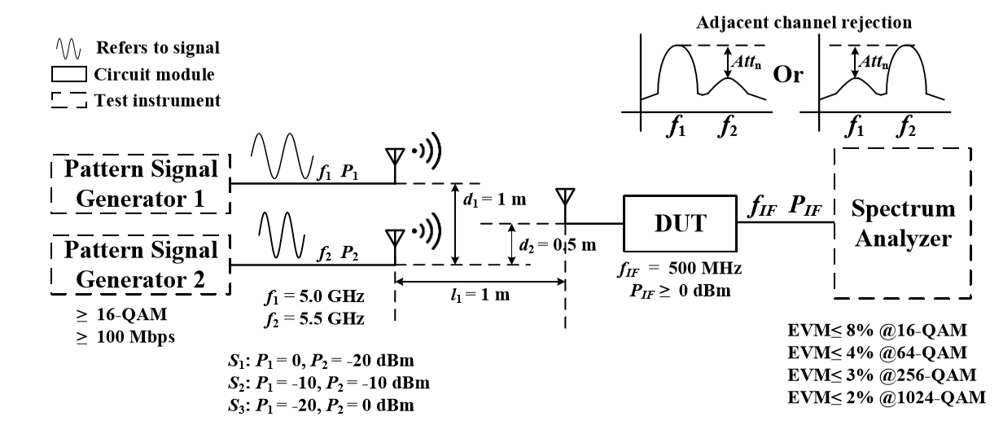
Figure 2. Test Setup.

The output port of the receiver must be a female SMA connector in order to be connected to the spectrum analyzer. Two signal generators (considered as the transmitter), a spectrum analyzer, a metered power supply (0-20 V, 0-3 A), and a digital multi-meter will be available on-site for the measurement. The receiver is to be placed between the signal generator (transmitter) and the spectrum analyzer (receiver) to exam its performances. The setup is shown in Figure 2 (l1 = 1 m, d1 = 1 m, and d2 = 0.5 m). The student competition participants should bring their designed receiver to the IMS competition hall for measurement. The signal generator, the spectrum analyzer and the power supply will be provided by the organizers on site for the measurement.

The measurements will be conducted as follows:

- The two transmitted signals are fixed at 5.0 GHz and 5.5 GHz, respectively;

- The power of two transmitted signals (P1 and P2) will vary and form three scenarios, i.e., P1 = 0 dBm with P2 = −20 dBm, P1 = −10 dBm with P2 = −10 dBm, and P1 = −20 dBm with P2 = 0 dBm, respectively.

3) Under each of the three scenarios, the maximum transmission data-rate in Mbps (Rb1, Rb2, and Rb3), the DC power consumption in mW (Pdc1, Pdc2, and Pdc3), and the adjacent channel rejection in dB (Att1, Att2, and Att3) will be measured. They will be used to score a receiver.

Notes:

1. The receiver is expected to detect the stronger transmitted signal and establish the communications with the stronger transmitted signal and ignore the weaker transmitted signal.

2. The locations of the antennas connected to the signal generators and the receiver are defined as locations of the transmitter and the receiver, respectively.

3. To keep the competition length within a reasonable amount of time, students will have maximum 10 minutes to tune their system before their test or measurements. Once the measurements start for each design, no tuning is allowed.

Evaluation Criteria
The following formulas are used to score each designed receiver:

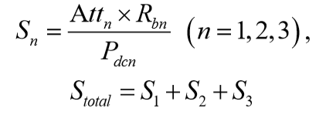
The team with highest scores will win the prizes!

How to Participate
Participants must register to the IMS Student Design Competition according to the rules posted on the IMS-2020 homepage. At the same time as the registration to IMS-2020 is made, the competitors must also register with the organizers of the competition. This is done by sending an e-mail containing the name of the team members and their contact details (e-mail preferred) to Xun Luo, xun-luo@ieee.org with the subject line “IMS-2020 SDC5: Spectrum sensing receiver” no later than the official deadline announced on the IMS-2020 SDC homepage and following the below format. The participating teams will be asked to give a 10-minutes oral presentation to the students and judges before the test starts.

Student Eligibility Criteria
- Students may enter as individuals or as a team. There may be no more than four students on a
team. Each student may be a member of only one team. Each team may submit up to one entry.

- To enter a competition, the student(s) must have been full-time student(s) (enrolled for a minimum of nine hours per term as graduate students or twelve hours per term as undergraduates) during the time the work was performed. There is no restriction on age.

- The student(s) must have a signed statement from their academic advisor that the work is principally the effort of the student(s).

- At least one of the students on a team must register for and attend the conference to demonstrate their design for evaluation during the contest day at IMS2020.

- The students should use the email address issued by their respective institutions for all communication regarding the competitions, rather than their personal emails (e.g., Gmail, Hotmail).

Awards
Yhe first-place winner will receive $1200, the second-place will receive $500, and the third-place will receive $300. The judges reserve the right to change this allocation based on the number and quality of the entries, possible tied scores and other unforeseen scoring situations. This will be a one level competition.

