Wide Frequency Coverage Tunable Bandstop Filter

Sponsors
MTT-5 (Microwave Filters)

Coordinators
Sanghoon Shin, Naval Research Laboratory
Eric Naglich, Booz Allen Hamilton

Competition Summary
Tunable bandstop filters are required in situations where wideband receivers could receive debilitating narrowband interference at any frequency over a wide bandwidth. Such filters need to be able to quickly and reliably be tuned to the frequency of an interfering signal to ensure that the receiver can continue to operate with high sensitivity. While multiple tunable bandstop filters have been presented in journals such as the IEEE Transactions on Microwave Theory and Techniques, few can operate over the wide bandwidths that will be involved with emerging technologies such as 5G NR. The goal of this competition is to create a tunable/reconfigurable bandstop filter that can operate at the lower and upper edges of bands n1-n75 in the 3GPP TS 38.101-1 wireless standard. Therefore, the filter must operate as low as 700 MHz and as high as 2600 MHz.

Detailed Competition Description and Rules
The objective of this Student Design Competition (SDC) is to design a tunable, switchable, or otherwise reconfigurable bandstop filter capable of having its center frequency set to either 700 MHz or 2600 MHz while providing high isolation in the stopband and low insertion loss in the passband. The wide frequency disparity between the two center frequencies poses the greatest challenge of this SDC. While it presents a significant challenge, the challenge will be equal for all teams, so don’t let it discourage you from trying your best.
- There are several approaches and combinations of approaches that can be used to accomplish this design, such as switched length resonators, a combination of switching and continuous tuning, higher order resonator modes, etc.
- In addition, the tunable bandstop filter can be composed of any type of lumped, planar, or cavity resonators and can use any type of reconfigurable element, including switches, varactors, or relays.
- The filter must have female SMA connectors on its edges for measurement by a network analyzer.
- The filter will be evaluated based on the performance measured between the SMA connector interface reference planes.
- A network analyzer and two voltage sources (0-20 V, 0-100 mA) will be available for measurements and filter reconfiguration.

Evaluation Criteria

Scoring of the filter will include measurements at center frequencies of 700 MHz and 2600 MHz. The measurements will assess the filters ability to provide attenuation at the desired center frequency and surrounding bandwidth and a low-loss passband response. A detailed description of the measurements and filter specifications follows.
The target 3 dB fractional bandwidth at 700 MHz is 6%, and it is 3% at 2600 MHz, i.e. 42 MHz bandwidth at 700 MHz and 78 MHz bandwidth at 2600 MHz. The 700 MHz measurement will record the following data:
1. Minimum attenuation from 689.5 to 710.5 MHz. For example, if the filter attenuation varies from 19.7 to 21.6 dB over the frequency range, the scored value will be 19.7 dB.
2. Maximum passband insertion loss from 100 to 670 MHz and from 730 to 1200 MHz. For example, if the passband insertion loss varies from 0.1 to 1.24 dB from 100 to 670 MHz and from 0.3 to 1.62 dB from 730 MHz to 1200 MHz, the scored values will be 1.24 and 1.62 dB.
3. The score for the 700 MHz measurement will be calculated by taking the minimum attenuation scored value and subtracting the two maximum passband insertion loss values. In the example above, the calculated score would be 19.7-1.24-1.62 = 16.84.
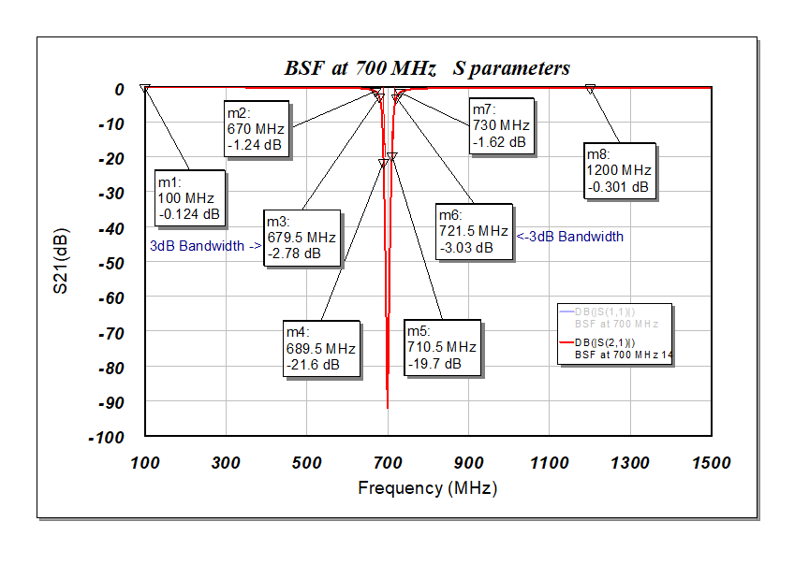
Fig. 1 Bandstop Filter at 700 MHz
The 2600 MHz measurement will record similar data:
1. Minimum attenuation from 2561 to 2639 MHz. For example, if the filter attenuation varies from 12.06 to 16.85 dB over the frequency range, the scored value will be 12.06 dB.
2. Maximum passband insertion loss from 100 to 2450 MHz and from 2750 to 3500 MHz. For example, if the passband insertion loss varies from 0.1 to 0.98 dB from 100 to 2450 MHz and from 0.39 to 1.15 dB from 2750 to 3500 MHz, the scored values will be 0.98 and 1.15 dB.
3. The score for the 2600 MHz measurement will be calculated by taking the minimum attenuation scored value and subtracting the two maximum passband insertion loss values. In the example above, the calculated score would be 12.06-0.98-1.15 =9.93.
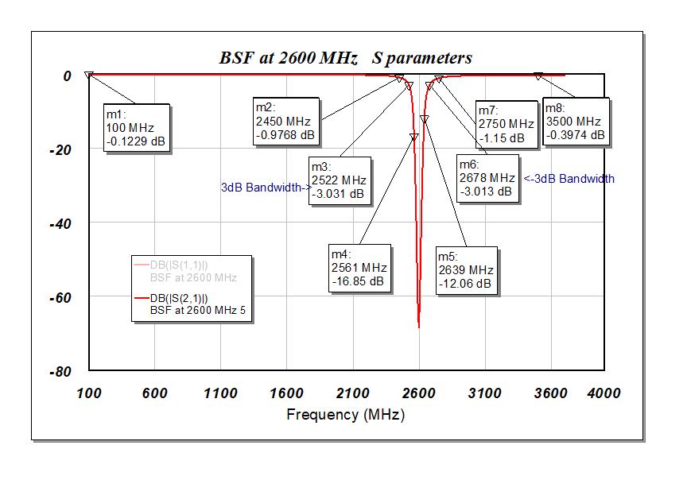
Fig. 2 Bandstop Filter at 2600 MHz

The final score for the filter will be the sum of the two measurement scores. In the example above, the final score will be 16.84+9.93 = 26.77. The team with the largest final scores will win the awards.
Note: The size of the filter will not influence the competition score in this SDC. Also note that the filter does not need to perform well at any center frequency between 700 MHz and 2600 MHz, which may affect your design strategy.
How to Participate
- Follow the instructions on the IMS2020 Student Design Competitions website to submit your student design competition application.
- Please also send a copy of the form to s.shin@ieee.org and eric.j.naglich@ieee.org.

Student Eligibility Criteria
- Students may enter as individuals or as a team. There may be no more than four students on a team. Each student may be a member of only one team. Each team may submit up to two entries but can receive an award for only one entry.
- To enter a competition, the student(s) must have been full-time student(s) (enrolled for a minimum of nine hours per term as graduate students or twelve hours per term as undergraduates) during the time the work was performed. There is no restriction on age.
- The student(s) must have a signed statement from their academic advisor that the work is principally the effort of the student(s).
- At least one of the students on a team must register for and attend the conference to demonstrate their design for evaluation during the contest day at IMS’20.
- The students should use the email address issued by their respective institutions for all communication regarding the competitions, rather than their personal emails (e.g., Gmail, Hotmail).

Awards
There will be three prizes awarded. The first-place award is $1200. The second-place award is $500. The third-place award is $300. In addition, the first-place winner is invited to submit a paper describing the design in the MTT’s Microwave Magazine.

